A ThingLink How To
1. Create an account – all you need is an email account. It’s free.
2. Log in
3. Select the Create Button at the top of the page.
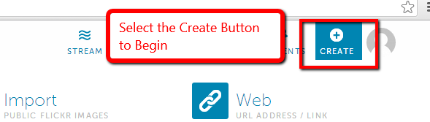

4. Choose your image for your background. This can be any picture. It is recommended that pictures are approved by teacher for use.
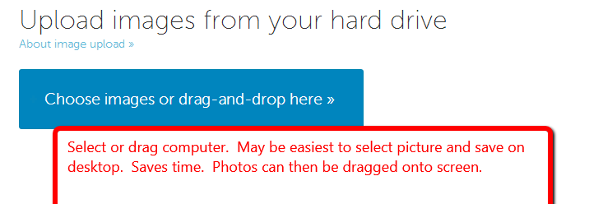

5. Name your image.
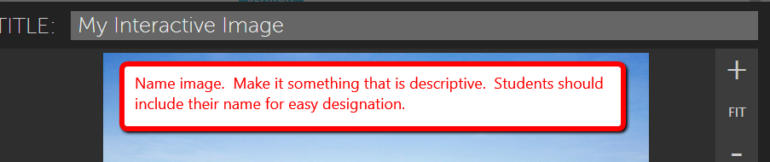
6. After naming your image – begin tagging or putting your “touches” on the picture. Select a location to make a tag and click. A screen pops up and you can add your things and links. 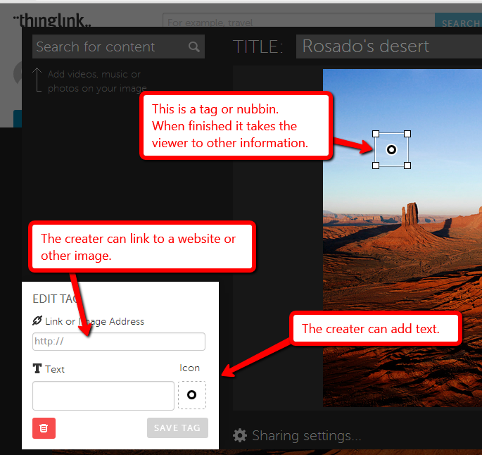
7. After adding each piece of information or tag – remember to Save Tag.
8. You can add as many tags to an image as you want. When you are finished select Save on the bottom right corner. Then you are ready to view your image.
9. Images can be shared by links or embedded into presentations or websites.
